L1-2 History Taking

1) Important Points of history taking
I) Control situation
1) Pen and notepad
2) Good timing
🡺Do the right thing at the right time
🡪Depends on patient mental, physical situation 🡺When to ask and when to answer
🡪Depends on patient characteristics
3) Privacy
4) Quiet, comfortable environment
5) Avoid distraction
II) Obtain most information
III) Extract useful information
⇨ About 20 min
2) Attitude of History taking
I) Establish communication
II) Show you are trying to help
III) Watch facial expression, posture
IV) Observe reaction
V) Read between lines for true message
3) Points to AVOID in history taking
I) Hostility
II) Impatience
III) Misled by PATIENTS interpretation, diagnosis IV) Interruption
V) Leading questions ***
🡺Should use OPEN QUESTION
🡪MC Q is preferred
4) Procedure of history taking
a) Introduction
I) Introduce yourself
II) Ask patients name and REMEMBER
III) Record age, occupation
IV) SHORT FRIENDLY chat
b) Presenting symptoms
I) Clearly define CHIEF COMPLAINT and WHY COMING TODAY II) Date, duration, hidden symptoms
c) Analysis of principal of symptoms (Present illness history)
I) Site | II) Progression
III) Type | IV) Radiation
V) Onset | VI) Effect
VII) Characteristic | VIII) Duration
IX) Provoking Factors | X) Severity
XI) Relieving Factors | XII) Accompaniment

d) Past medical history
I) All illness and operations
🡺Complication, progression, date, duration
II) Present treatments
e) Medication and allergies
I) Side effect
II) Allergies
🡺Sea food allergies – May be iodine allergies ***
🡺Egg allergies – Concerned before vaccine injection
🡺Pork allergies – Concerned before
f) Family History
🡺AGE and DATE ****
🡺Infection and Genetic
🡺Direct / indirect effects **
g) Review of Systems
🡺Summarize, clarify, link, enquire extra, Detect hidden
h) Social and personal history
🡺Occupation, smoking, drinking, home, psychological profile, eating 🡺Travel
🡺Caring Status ****
i) Summary
🡺Problem
🡺Diagnosis
🡺PLAN
j) Record
🡺Name, ID number, year old, gnder
5) Physical exam 5C
🡺Consent
🡪By action / 口頭
🡺comfort, calm, controlled, complete
6) Physical exam procedure
I) Inspection
II) Palpation
III) Percussion
IV) Auscultation
7) Part of physical exam
a) General
🡺Vital stats
🡪BP, age, gender etc.
b) Regional
I) Neurological
🡺Orientation, Mental level, consciousness, muscle power etc. II) Physiological
🡺Ditressed, mood, memory etc.
III) Nutritional
🡺Obese, well/under nourished, Cachexic (肌肉萎縮)
IV) Circulation
🡺Central/peripheral cyanosis, pallor, jaundice, ankle edema V) Cutaneuos
🡺Inflammation, induration, ulceration, scratch marks
VI) Lymphatic
🡺Palpation of lymph nodes in 2 or mo re areas
VII) Specific
🡺Spider naevi: liver disease
🡺Cushingoid: hyper-secretion of adrenaline

L3 Abdominal Pain

# History taking
- onset
- duration
- site (epigastric/lumbar/illac/hypogastric)
- radiation
- Character of pain（dull/stabbing/colicky/numbness/burning/tingling）
- Severity
- Aggravating?Relieving factors(movement/posture/food intake/bowel motion/medication)
- Associated Symptoms
- Constitutional Symptoms
- Quality of life

- Associated symptoms:
- rectal bleeding/blood in stool
- cramping or steady abdominal pain
- change in bowel habits
- loss of appetite
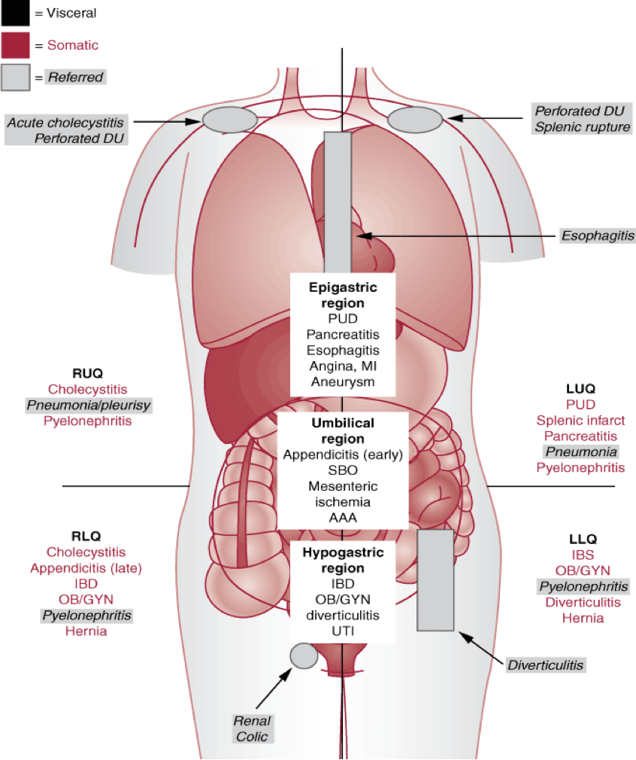

A）Sepsis（ intra-abdominal sepsis）
- majority
- sign: fever/hypothermia,tachycardia 心動過速,tachypnoea呼吸過速

B）Peptic ulcer
- risk factors：
- Helico/bactor pylori
- Aspirin, Non steroidal anti-inflammatory drugs (NSAID)
- Smoking

- Complications：
- Bleeding：Chronic (slow: anaemia。Acute, fast: melaena/ hematemesis)
- Perforation
- Obstruction i.e. Gastric outlet obstruction

C）Perforated peptic ulcer
- Symtoms：
- Sudden onset severe epi/gastric pain（upper abdominal pain）
- Broad like rigidity
- Fever/ Sepsis/Shock

- Diagnosis：
- Typical history and physical sign
- Erect Chest X-Ray
- Free gas under diaphragm occurs in 70%
- If in doubt, diagnostic laparoscopy or CT (computed tomography)

D）Ruptured abdominal aortic aneurysm（AAA）
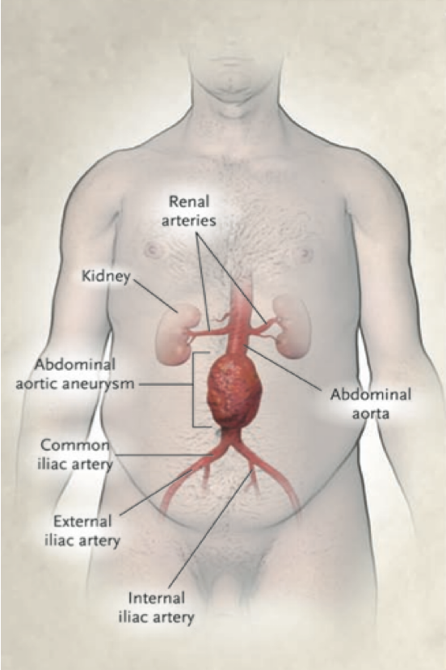
- Aortic aneurysm
- A permanent localized dilatation of aorta
- Normal ~2cm
- Aneurysmal if >3cm
- Associated with smoking, hypertension, and COPD(Chronic Obstructive Pulmonary Disease)
- 7 male : 1 female

- Presentation
- Sudden onset very severe abdominal pain
- Sometimes radiates to back
- Shock，Pallor
- Abdominal distension腹脹
- Expansile膨脹的abdominal mass

E）Hepato/cellular carcinoma 肝細胞癌 (HCC)
- Cause：
- Hepatitis B viral infection: 80%
- Hepatitis C viral infection: 5%
- Heavy ethanol intake: 5%
- Aflatoxin 黃麴毒素
- Presentation
- Sudden onset very severe RUQ pain/ generalized abdominal pain
- Abdominal distension
- Shock，Jaundice (no fever Dx with Cholecystitis)
- Stigmata of chronic liver disease（palmar erythema,Flapping tremor,clubbing,Dupuytren’s contracture,white nail）(Scattered Telangiectasia,Spider Angioma,Jaundice)
- Hepatomegaly
- History of hepatitis
- tumour marker AFP

F）Acute chole/cystitis 急性膽囊炎
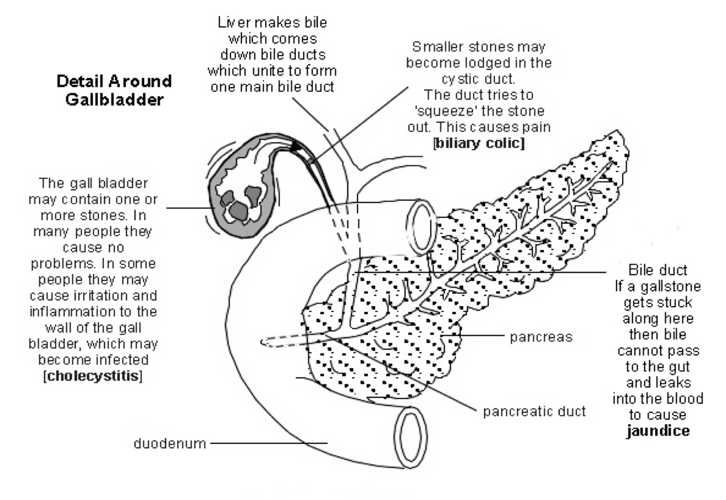
- Presentation
- RUQ pain, Acute onset
- Fever, Jaundice
- History of gallstone/ biliary colic
- Murphy sign（墨菲氏病癥(Murphy's sign)，檢查方式為：先請病患把氣呼出，並將手按壓於病患的右上腹的右肋骨下，接著請病患者用胸部深呼吸，此時會引發上腹部疼痛的症狀，使病患無法吸足氣。）
- Characteristic
- Biliary colic 膽絞痛 → usually self limiting
- Acute cholecystitis
- Fever & jaundice are red flag sign
- Refer surgeon

G）Acute appendicitis 急性闌尾炎

- Presentation
- Presentation can be variable
- Acute onset
- Classically starts with peri/umbilical pain that radiates to RLQ
- Usually with fever
- +/- Diarrhea & vomiting
- McBurney’s sign（by palpating the point in RLQ）
- In female patients
- Pelvic inflammatory disease/Ectopic pregnancy異位妊娠/Complication of ovarian cyst
- Gynecological history

- Investigation for RLQ pain
- Blood test for leukocytosis（白血球增多症=發炎反應）
- Ultrasound
- Computed tomography
- Mid stream urine for microscopy & culture
- Pregnancy test in female patients

H) Chronic abdominal pain
- common complaint
- suspicious of malignancy

L4 Investigation in Surgical patients

# General principles
- I. Aid / Confirm diagnosis
- II. Plan for treatment options
- III. Assess progress of disease & response to treatment

# Main methods

A) Laboratory
- Complete blood count
- Haemoglobin, WBC count, bone marrow, platelet count
- Clotting picture (APTT / INR)
- Deranged as result of sepsis, liver disease, anticoagulation drugs, herbal medicine
- Unsafe for operation if deranged
- Renal function test (RFT)
- Na, K-electrolyte balance, hydration
- Urea/Creatinine (Direct kidney function)
- Liver function test (LFT)
- Bilirubin, ALP
- Liver enzymes (ALT, AS)
- Albumin (Reflection of function of liver and nutrition status)
- Glucose
- By Hemstix test ** Hemastix test

- Tumour marker
- Alpha feto-protein (AFP)
- Hepatocellular, cirrhosis, testicular tumor
- Prostate specific antigen (PSA)
- Prostatic cancer
- Carcinoembryonic antigen (胚胎原蛋白)
- Cancer of stomach, large and small intestine, Also breast , lung cancers ,Smoking
- Ca19.9
- Cancer of pancreas
- Ca125
- Cancer of uterus

- Infection marker
- Hepatitis , HIV, Syphilis 梅毒
- Blood culture
- Sepsis: Replication of bacteria in blood
- important in identifying cause of sepsis and administration of correct antibiotics
- Other body fluids examination
- Urine, sputum, abdominal fluid, pleural fluid,CSF
- Infection: WBCs, culture for pathogens ?
- Red cells: Bleeding (Inflammation ? Trauma by stone ? malignancy?)
- Presence of malignant cells

B) Radiology (Imaging of various organs)
- Plain X ray
- Advantages: Cheap
- Good to show bone, stone, foreign body air-tissue interface
- Disadvantage: Radiation, cost
- Contrast X-ray
- Contrast For mucosal lesion in luminal organ
- E.g. Barium swallow
- Disadvantage: Radiation, aspiration of contrast, cost
- Angiogram
- Contrast in the vessels
- Diagnosis Stenosis, Aneurysm
- Side effect: Vessel injury from puncture,Bleeding ,Contrast toxicity,Radiation
- Ultrasound
- Good for solid organ, blood vessels and fluid collection
- No side effect***
- Accuracy of result depends on operator
- CT scan
- Multiple X ray constructing 3-D images
- fast, good quality image
- demonstrate morphology change of organ
- tumor, infection(abscess), arterial/venous disease(aneurysm, occlusion)
- Cons: Expensive, toxic from contrast, high dose radiation(pregnancy contraindicated)
- MRI
- Proton excited/aligned by magnetic field and then relax & returned
- Quality depends on hydrogen content ** (Water, fat)
- pros: no radiation,minimal side effect
- cons: slow scanning, more expensive, not for claustrophobia. 幽閉恐懼

C) Endoscopy (Visualize and examine inside of luminal structure)
- Colonoscopy, Bronchoscopy, Etc.
- For biopsy
- For Therapeutic procedure
- Removal of polyp, homeostasis

D) Cytology / Histopathology

L5 Abdominal Spasm Colic 腹絞痛

A）Intestinal Obstruction
- Pathophysiology
- Distension of bowel with fluid and gas
- Excessive peristalsis
- Decreased absorption and extravasation of fluid into bowel lumen
- Impaired blood supply ( strangulation )
- Peritonitis
- Symptoms
- Colicky abdominal pain
- Abdominal distension
- Constipation
- Vomiting
- Physical Findings
- Dehydration
- Distended abdomen
- Visible peristalsis
- Hernia
- Hyperactive bowel sounds
- Signs of Stran/gulation（腸絞扼=血液灌流減少（strangulation）的腹痛通常是突然且劇痛）
- Constant abdominal pain
- Fever，Shock
- Peritoneal signs(colicky abdominal pain, abdominal distension)
- Leukocytosis
- Metabolic acidosis
- Impaired liver functions
- General Management
- NPO 禁食
- Fluid replacement
- Nasogastric tube 鼻胃管
- Monitor vital signs
- Correct electrolyte disturbance

1. Small Bowel Obstruction ()
- Adhesive Obstruction
- Treatment：
- enterolysis (the separation and removal of intestinal adhesions)
- resection of nonviable bowel
- External Hernia
- Treatment：
- repair of hernia
- resection of nonviable bowel
- Virgin Abdomen (obstruction but never had surgical process)
- Intussusception 內摺: one portion of small bowel becomes invaginated into the adjacent segment of bowel
- volvulus 腸紐結: twisting of bowel
- gallstone ileus 膽石性腸阻塞: obstruction of small bowel by gallstone
- small bowel tumour
- internal hernia
- bezoar 腸胃結石

2. Large Bowel Obstruction
(urgent colonoscopy within 24hrs)
- 90% Carcinoma
- Treatment:
- Resection 切除
- primary anastomosis切口吻合朮
- stenting
- Volvulus 扭轉
- most common at sigmoid colon乙狀結腸（descending/ascending/transvers）
- Treatment：
- Colono/scopic decompression結腸鏡減壓(successful in 80% Sigmoid colectomy)
- Sigmoid colectomy乙狀結腸切除
- Pseudo/obstruction 假性腸隔阻：
- Dilatation of bowel without mechanical obstruction.
- Treatment:
- colonoscopic decompression
- insertion of flatus tube 排氣管
- Caeco/stomy盲腸（caecum）造口朮

B) Haematuria尿血
- Neoplasm
- Calculi 尿結石
- composition: calcium oxalate, magnesium ammonium phosphate,uric acid,calcium phosphate,cysteine
- presentations: loin pain,iliac fossa pain perineal pain, hydronephrosis,hydroureter,urinary tract infection.
- Trauma
- non-penetrating injury: blunt trauma閉合性損傷, deceleration injury,
- penetrating injury: gun shot, stabbing
- indirect injury: pelvic fracture
- iatrogenic injury 醫源性損傷: transurethral surgery, abdominal or pelvic surgery, urethral catheterisation
- Infection
- Acute:EColi,Klebsiella,Pseudomonas,Streptococcus,Staphylococcus,Bacteroides
- Chronic: Mycobacterium tuberculosis
- predisposing factors: obstruction, calculi,vesicoureteric reflux, systemic disorder (eg.DM),urethral catheterisation
- Miscellaneous
- Benign prostatic hyperplasia
- Polycystic kidney
- Cyclophosphamide
- Vascular malformation
- Anticoagulation
- Microinfarcts
- Glomerulonephritis
- IgA nephropathy

L6 Jaundice and hepatobiliary Disease

A) Jaundice
- yellow discoloration of the skin due to high serum bilirubin lv.

B) Gallstones
- characteristics:
- hard, pebble‐like deposits that form inside the gallbladder.
- Cholesterol stones(common)/Pigment stones(too much bilirubin in bile)

- Risk factors:
- females, middle age, obesity
- failure to empty bile from gallbladder
- liver cirrhosis
- Investigation:
- liver ultrasonography
- CT scan
- Management:
- laparo/scopic cholecyst/ectomy 腹腔鏡膽囊切除手術
- percutaneous transhepatic cholecystostomy
- Complications
- acute cholangitis
- acute pancreatitis
- empyema膿 of gallbladder
- gallbladder gangrene壞死
- mucocele of gallbladder
- choledochoduodenal fistula

C) Acute Cholangitis 急性膽管炎
- infection of the biliary tract due to bile flow obstruction.
- Charcot’s triad: fever, jaundice, abdominal pain

- Investigations:
- blood tests: complete blood tests; renal and liver function tests; coagulation profile, type and screen.
- microbiology: blood c/st
- Imagings：
- Liver ultrasonography: bile duct diameter, presence of stones,liver abscess
- CT acan
- Treatment
- endoscopy : Endoscopic retrograde cholangiopancreatography (ERCP)
- surgical：Exploration of common bile duct
- radiological：Per/cutaneous trans/hepatic biliary drainage 經皮穿肝膽引流朮

D) Acute pancreatitis
- sudden onset epigastric pain, radiation to back
- Usually associated with nausea and vomiting
- high fever (uncommon) implies complications
- Complications:
- Pseudocyst 假性囊腫
- Infected pseudocyst
- Necrotising pancreatitis #急性壞死性胰臟炎
- treatment:
- Conservative treatment with nutritional support and intravenous antibiotics
- Necrosectomy for infected necrosis
- Approach for necrosectomy: endoscopic, open approach
- Hemorrhagic pancreatitis
- Pleural effusion
- Ascites
- Splenic Vein thrombosis

E) Cholangio/carcinoma
- 2%of all cancers
- risk factor: advanced age (peak 70-80)

- Presentation:
- painless jaundice
- weight loss
- loss of appetite
- fever

- Treatment
- Curative: hepatectomy + bile duct excision+hilar lymph node clearance+bile duct reconstruction
- Palliative:radiotherapy, chemotherapy,metallic stenting/surgical bypass

F) Recurrent Pyogenic Cholangitis 復發性化膿性膽管炎
- repeated attacks of bacterial infection of the biliary tract as a results of stone and strictures in the bile ducts
- esp. in the intrahepatic segments.
- Pathogenesis
- entry of bowel organisms into bile ducts
- initiate inflammation in the portal triad resulting in necrosis of hepatocytes
- Cholangio/hepatitis leading to fibrosis and cholangitis abscess formation
- bilirubinate stones/stricture formation
- Characteristics of RPC: infection, stricture formation,stone formation
- Causative organism: clonorchis sinesis 肝吸蟲（Liver fluke，flatworm）
- Stone: bilirubinate stones
- Striction formation:
- common in left main hepatic duct or segmental ducts
- in main duct usually short segment
- intrahepatic strictures usually long-segment
- proximal dilatations behind the strictures
- Presentation
- pain, fever, jaundice
- Investigation
- liver ultrasonography（Ultrasound）
- Computer tomography(CT)
- Magnetic resonance imaging(MRI)
- Endoscopic retrograde pancreato cholangiography(ERCP)
- Percutaneous transhepatic cholangiogram(PTC)

- Clinical Manangement
- Acute attack
- Non-operative approach
- Operative approach
- exploration of common bile duct
- drainage of pus and infected bile
- removal of stones within common bile duct
- Definitive treatment
- obj:
- remove biliary ductal stones
- to enlarge or bypass strictures
- to provide adequate biliary drainage
- to provide permanent percutaneous access to the biliary tract

- Surgical options:
- Hepatico/jejuno/stomy (allow passage of bile sludges and stones into small bowel)
- Hepaticojejunostomy with a cutaneous stoma i.e. hepatocutaneous jejunostomy(provides a percutaneous route for future stone removal via choledoscopy)
- Hepat/ectomy
- For destroyed liver segment
- Intrahepatic strictures and stones
- Multiple liver abscess
- cholangiocarcinoma

- Fiber‐optic choledochoscopy 纖維膽道鏡聯合腹腔鏡治療

- Complications
- Liver abscess
- Choledochoduodenal fistula
- Acute pancreatitis
- Portal vein thrombosis
- Biliary cirrhosis
- Cholangio/carcinoma

- Outcome of treatment
- Long‐termoutcomes
- Stone recurrence: 9%
- 5‐year survival
- With cholangiocarcinoma: 9%
- Without cholangiocarcinoma: 93%

G) Pancreatic cancer
- highly lethal cancer, even if resectable
- peak onset age >60s
- asymptomatic in early cancer
- clinical presentation often indicates advanced diseases.
- Curative treatment
- radical pancreaticoduodenectomy (Whipple operation)
- excision of pancreatic head
- excision of duodenum
- excision of common bile duct
- partial excision of stomach
- reconstruction to restore GI tract continuity
- pancreaticojejunostomy
- hepaticojejunostomy
- gastrojejunostomy

- Palliative treatment
- double bypass+coeliac axis block
- Gastrojejunostomy
- Hepaticojejunostomy
- metallic steenting
- radiotherapy
- chemotherapy

L7 Dysphagia 吞嚥困難, melena 大便色黑 ,Haematemesis 嘔血

Dysphagia 吞嚥困難

A）History taking
- Duration of symptoms
- Progressive dysphagia? (significant)
- Level of obstruction/hold up
- Current diet (fluid/soft/solid diet)
- Weight loss
- Associated symptoms (e.g. acid reflux/epigastric pain etc)
- Smoking/drinking history
- Place of origin

Difficulty in swallowing：
- Esophagus
- Mechanical obstruction
- Neuromuscular
- Oropharyngeal dysphagia口咽吞嚥困難
- neuromuscular disease

Mechanical Obstruction
Intraluminal (acute onset）：
- Foreign body，Food bolus
Wall
- Cancer of esophagus
- Submucosal lesion of esophagus e.g leiomyoma, GIST 胃腸道基質細胞瘤
- Stricture (e.g. caustic, peptic, radiation, medication)
Extraluminal (Extrinsic compression)：
- Mediastinal lymph node/mass, retrosternal goiter
- Vascular compression

Neuromuscular disorders
- Sclero/derma 硬皮病（皮膚細胞硬化）
- Acha/lasia(食道唔郁，有野long住) 食道賁門弛緩不能症（由于食管括约肌弛缓不全致使无法正常吞咽）
- Spastic motor disorder（diffuse esophageal spasm,nutcracker esophagus etc）

Neurological disease:
- Cerebrovascular accident, Parkinson’s disease
- Brainstem tumor
- Myopathy (e.g. muscular dystrophy)
- Myasthenia gravis
- Peripheral neuropathies
- Degenerative disease (e.g. multiple sclerosis)

B）Physical examination
- Hoarseness of voice(喉返神經附近，受壓)
- Cachexia惡病質(malnutrition)
- Cervical lymphadenopathy(supraclavicular nodes 後期)
- Others: goiter, cranial nerve palsy
- May not have positive physical signs

C）Investigations
- OGD(from throat to duodenum)
- Barium swallow（one造影劑）
- CXR
- CT scan/PET-CT scan (for distal metastasis)

Other investigations: high resolution manometry(HRM), 24 hr pH study (selected patients)
- Speech therapist: VFSS
- Physician/neurologist consultation

OGD內窺鏡
- PET-CT scan正電子
- OGD → biopsy
Cancer of esophagus
- usually squamous cell carcinoma (SCC),
- middle third PET-CT → staging (lymph node metastases, distant metastases)

D）Management
- High aspiration risk -> may need non-oral feeding (e.g. tube feeding, gastrostomy feeding)
- Treat underlying cause

# Management According to the cause of dysphagia:
- Cancer of esophagus
- Early stage: endoscopic treatment內窺鏡治療/esophagectomy(ensure no lymph met)
- Advanced stage: neoadjuvant chemoradiation followed by esopha/ectomy
- Palliation: palliative radiotherapy/metallic stenting
- Achalasia食道賁門弛緩不能症
- Endoscopic treatment: peroral endoscopic
- myotomy (POEM); pneumatic dilatation etc
- Surgery: laparoscopic Heller’s myotomy
- Palliative treatment：Metallic stenting
- Endoscopic procedure under fluoroscopy

Haematemesis/melena
- Upper GI bleeding (esophagus, stomach or duodenum)

Haematemesis
- vomit blood
- Ddx: haemoptysis咯血, epistaxis鼻衄

Melena
- passage of tarry 拖延的 stool
- Ddx: dark stool (grayish-black) in patients taking iron supplement

Haematemesis
Causes
• Esophagus: esophageal varices食道靜脈曲張, esophagitis, Mallory-Weiss tear食道裂傷
• Stomach: gastric ulcer, gastritis, malignancy, gastric varices, hypertensive gastropathy, GIST 胃腸道基質細胞瘤 etc.
• Duodenum: duodenal ulcer
• (Small bowel tumor/GIST/ulcers)

Aim of management
• Resuscitation 甦醒；恢復知覺
• Identification of origin of bleeding + haemostasis
• Prevention of rebleeding
• Definitive management

Investigations
- Blood tests including CBP, LRFT, Clotting profile, Type & Screen 血液分型與抗體篩檢（for transfusion) , ABG (arterial blood gas)
- Chest X-Ray (to exclude free gas under diaphragm)
- OGD 胃腸鏡
- Urgent: suspect active bleeding
- Emergency (within 24 hours)
- Airway protection (if indicated) and T&S available before OGD; Correction of coagulopathy凝血障礙
- Blood/blood product transfusion, Volume replacement

OGD
- Identify the site of bleeding/pathology
- Endoscopic haemostasis止血 if indicated (one or more of the following)
- Injection of adrenaline
- Heater probe
- Band ligation for esophageal varices
- Argon plasma coagulation
- Endoclips(Hemoclip止血夾)

Post OGD
- Medication: proton pump inhibitor (PPI) x 6-8 weeks
- Top up hemoglobin
- Watch out for re-bleeding (tachycardia, hypotension, passage of melena etc)

Rebleeding
- Operative management may be necessary if failed endoscopic haemostasis
- Intervention- Surgery
- Failed haemostasis：Operative approach depends on the pathology
- Ulcerectomy/partial gastrectomy may be required in bleeding gastric ulcer

Follow-up
- Helicobacter pylori (HP) eradication 根除(Urea breath test to confirm clearance of HP)
- Quit smoking
- Rescope (usually at 6 weeks) for gastric ulcer, biopsy if unhealed
- Nonhealing GU
- Check drug compliance – noncompliant, resistance
- Risk factors (smoking, HP status, NSAID)
- Malignancy, workup (e.g. CT scan) if indicated

SCC can be metastasis to peritoneal region
Globus sensation like 梅核氣

Highlights：

Cancer of esophagus: squamous cell carcinoma
- Dysphagia (painless progressive), weight loss
- Risk factor: smoking, drinking
- Treatment intent: curative or palliative (depends on DISEASE factor and PATIENT factor)
- Treatment modalities
- Surgery
- Radiotherapy
- Chemotherapy
- Endoscopic (e.g. stenting) for palliation

Gastric cancer: adenocarcinoma腺癌
- Epigastric pain, anemia, weight loss
- Risk factors: H pylori, smoking, diet, pernicious anemia, family history etc
- Treatment modalities:
- Surgery (gastr/ectomy)
- Chemotherapy
- Palliative radiotherapy (for hemostasis：hemoclip/adrenaline inj)

L8 Peripheral Arterial Disease & Varicose Veins週邊動脈疾病和靜脈曲張

Intermittent claudication 間歇性跛行

- Pain in muscle groups(usually calf, but may affect thigh, buttock, arms)
- After walking some distance，Worse hurrying,up/ downhill,stairs
- Relieved by short rest
- single-lv stenosis/occlusion cause claudication
- multi-lv stenosis狹窄/occlusion阻塞 casue rest pain/tissue loss

History:
- Speed of onset：May reflect etiology (embolism vs thrombosis in-situ / atherosclerosis )
- Which muscle groups：May indicate the level of arterial stenosis/Occlusion

Ischaemic Rest Pain
- pain in the forefoot, toes or ankle
- Aggravated by elevating the leg
- Improved by placing the leg in dependent position
- Caused by hypoxia 缺氧 of the cutaneous nerves
- Frequently worse at night
- Lack of gravity-induced increase in arterial blood flow
- Lower mean arterial pressure/perfusion pressure during sleep
- Patients may need to sleep in a chair to keep the foot in dependent position

Ischaemic ulcers / gangrene壞疽
- Usually in toes/heel/pressure points
- Ulcers are unhealthy with punched out edges
- Lack of granulation tissues
- Painful(apart from diabetics)

Ischaemic ulcers/ gangrene in Diabetics
- Peripheral arterial disease
- Macrovascular (usually infra-popliteal disease)
- Microvascular
- Peripheral neuropathy 周圍神經病變
- Prone to sepsis
- Poor healing
- Poor glycaemic control

Examination

- Inspection
- intermittent claudication may have no clinical signs on inspection
- severe lower limb ischaemia
- Thin atrophic nails/ skin
- Previous toe amputation
- Ulcers: toes, heel, pressure points of foot/ ankle
- Previous surgical scars for bypass surgery
- Pale on elevation and dependency hyperaemia (Buerger’s test)

- Palpation
- Capillary return of toes
- Temperature
- Pulses
- Femorals
- Popliteals
- Pedal pulses

- Auscultation
- Bruits散佈
- Cardiac bruits
- Cardiac murmur
- Abdominal or femoral bruits

Ankle brachial pressure index (ABI)
- Normal ABI is 1.0 to 1.1
- If lower, worse arterial disease
- Claudication 0.6 +- 0.2
- Rest pain 0.3 +- 0.1
- Tissue necrosis 0.1 +- 0.1

Other tests

- Arterial Duplex ultrasound
Limitations：
- User dependent, machine dependent
- Obscured by dressings / wounds
- Time consuming
- Atherosclerosis

- Angiogram 動脈造影
- CT angiogram / MR angiogram
- Intra-arterial digital subtracted angiogram IADSA (INVASIVE)
- Name the artery and divided into thirds (proximal,middle,distal)
- Describe degree of stenosis 狹窄
- Length of stenosis
- Run-off vessels 逕流

Acute lower limb ischaemia
⇨ Have to undergo surgery in the first 6 hours !!!!!
- Pain
- Perishing cold超級凍
- Pallor
- Pulselessness
- Parasthaesia感覺異常
- Paralysis 麻痹

Varicose Veins 靜脈曲張
- More common in women (3.5:1)：
- Pregnancy aggravates veins
- More symptomatic in women (cosmetic concerns)
- Tortuous dilated cutaneous veins
- Primary trunk incompetence 無能
- Long/ short saphe/nous veins 大隱靜脈
- Secondary trunk incompetence
- Acting as collaterals繼發性 in the presence of damage, occluded, or absent deep veins (usually severe skin changes and not much vvs)
- Factors: venous reflux,venous obstruction,obesity,prolonged standing
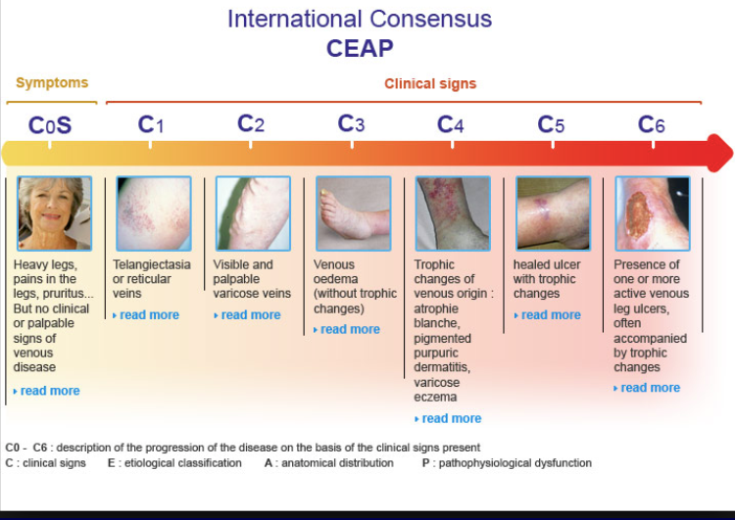

Examination of Varicose Veins
- Are there any varicose veins (tortuous and dilated)
- What distribution? (LSV, SSV, deep, combination)
- Are there any complications（mixed of artery and veins)
- Eczema / itchiness
- Pigmentation
- Lipo/dermato/sclerosis 脂性硬皮病
- Ulcerations
- Tourniquet tests
- PulsesTap test /Cough test
• Handheld doppler with calf squeeze manoeuver

Investigation of varicose veins

• Duplex ultrasound
– Sites of reflux
• Saphenofemoral junction/ long saphenous vein
• Saphenopopliteal junction/ short saphenous vein
• Deep veins
• Perforators

Duplex Assessment

Venous Ulcers
• Typical ankle area
• Pigmentation
• Size
• Sloping edge
• Slough/ granulation at base

